|  |
| --- |
| Close-up image showing the leaf-sides of two oversized books side-by-side on a bookshelf, with additional books in soft focus background |
| UI/UX Design of an E-Commerce Website using Adobe Photoshop CC.  Students:   1. Bilal Ahmed Khan (20k-0183) 2. Zulnoor Siddiqui (20k-1090) 3. Mohammad Wamiq Akram (20k-1857) |
| |  |  |  | | --- | --- | --- | | ousaid |  |  | |

1. **Making the Outline of the webpage:**

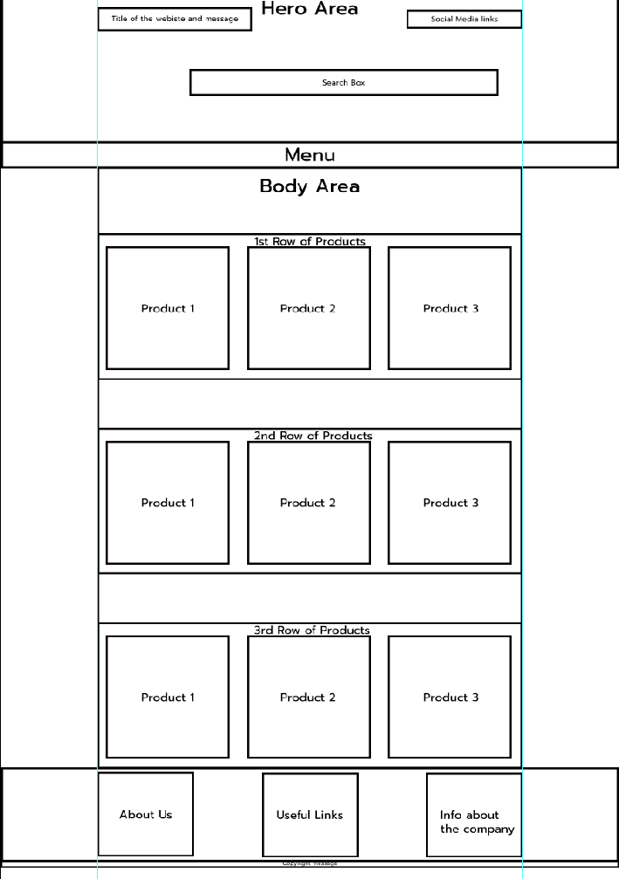

**Tools used in making the outline:**

1. Rectangle Tool
2. Rectangular Marquee tool (For Selection Purposes)
3. Move Tool (For accurate placement of each element)

**Procedure:**

STEP 1;

First of all we use rectangular shape tool in order to customized our ‘HEADER AREA’ , ‘BODY AREA’ and use for making an area where we list our product with different width strokes and height.

STEP 2:

We use rectangular marquee tool for the sake of selection with in a rectangle and use ‘MOVE TOOL’ in order to place the selections on respective places and make our working accurate.

1. **The Header of the webpage:**

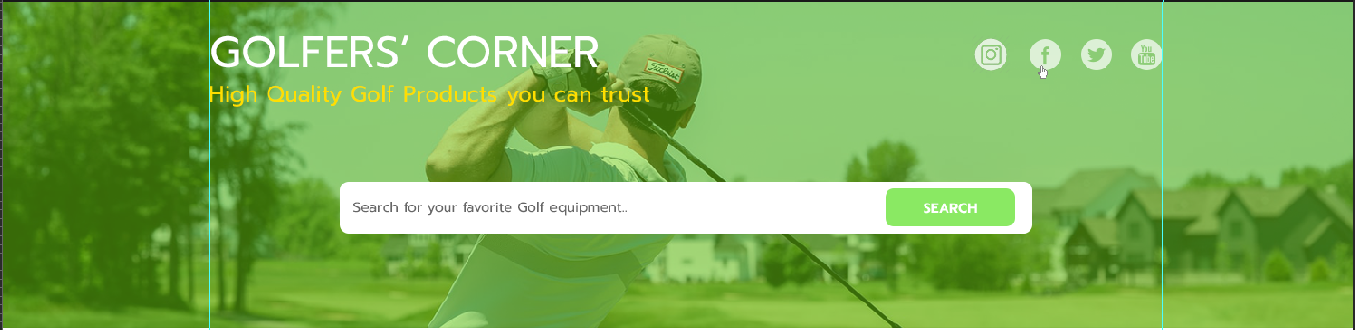

**Tools Used:**

1. Rectangle Tool
2. Rectangular Marquee tool (For Selection Purposes)
3. Move Tool (For accurate placement of each element)
4. Layers Panel for editing the opacity of the background image
5. Character panel for selecting font and managing typography

**Procedure:**

STEP 1: first we draw background with the help of rectangular tool.

STEP 2: Downloads an image from “unslpash.com”.

STEP 3: By the help of MOVE TOOL we adjust the downloaded photo on background rectangle.

STEP 4: We select both the layers (background and downloaded image) and creates ‘CLIPPING MASK’ and drops-down the opacity.

1. **Menu of the webpage:**

**Tools Used:**

1. Horizontal type tool
2. Character panel

**Procedure**

STEP 1:

Similarly we again draw a triangle with the help of rectangular tool.

STEP 2:

Using the text boxes we created our menus and aligned them by the help of spacing

STEP 3:

As we can see ‘flash sales’ option is selected or active for this we draw a rectangle and fill it with green color, than we selected the three point of the upper line of rectangle and drag the midpoint upward to give sharp arrow shape.

1. **Product Box:**

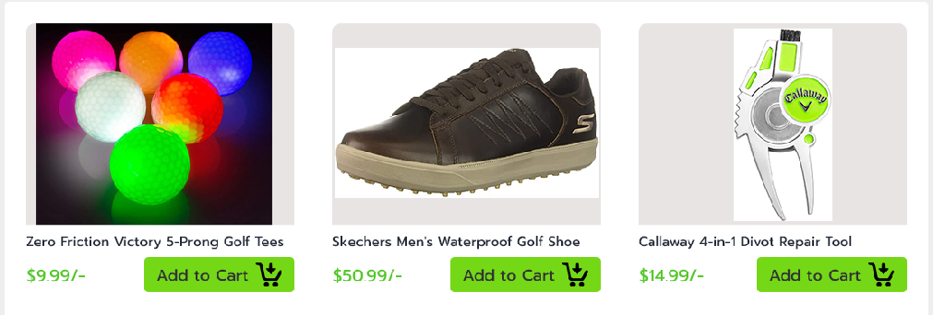

**Tools Used:**

1. Rectangle Tool (For making Add to Cart button)
2. Rectangular Marquee tool (For Selection Purposes)
3. Move Tool (For accurate placement of each element)
4. Layers Panel stacking the layers in orderly manner on each other
5. Character panel managing typography
6. Clipping masks for joining the picture of the product to the background triangle

**Procedure:**

STEP 1: first we draw rectangles to list our product by the help of ‘RECTANGULAR TOOL’.

STEP 2: In other layer we attached the product images.

STEP 3: By the help of ‘CLIPPING MASK’ we combined both the layers in order to fit our images to the customized rectangles.

STEP 4: By using ‘TEXT TOOL’ we created the price list and title of the product over another rectangle.

1. **Bottom of the webpage:**

**Tools Used:**

1. Move Tool (For accurate placement of each element)
2. Character panel for managing the line spacing and other elements of the typography
3. Rectangle Tool (For making the background rectangle)

**Procedure:**

As shown in above photo we created Three sections:

1. About Us
2. Important links
3. Info about the company

STEP 1:

We created three different sections by the help of ‘HORIZONTAL TYPE TOOL’ and entered the desired text

STEP 2:

Using ‘CHARACTER PANEL’ we managed all the ‘TYPOGRAPHY’ and arranged all the text elements accurately.

**And after all the elements of the webpage have been completed the final form is as follows:**

